## **Flight Delays and Cancellations Project**

**Which airports have the worst delays?**

* Links to your dashboards or story:

https://public.tableau.com/views/Whichairlinesorairportshavetheworstdelays1_1/Whichairlinesorairportshavetheworstdelays1_1?:language=en-US&:display_count=n&:origin=viz_share_link

* Summary:

In the files we carry out an analysis to find out first line, which are the airports with the worst delay? Analyzing each one of the data collected and taking as a basis only the data where the "Delays" are framed and later adding each of them to obtain "airports of total delay ". And thus know which airport is the worst of them and order it in descending order, to facilitate the obtaining of this.

* Design:

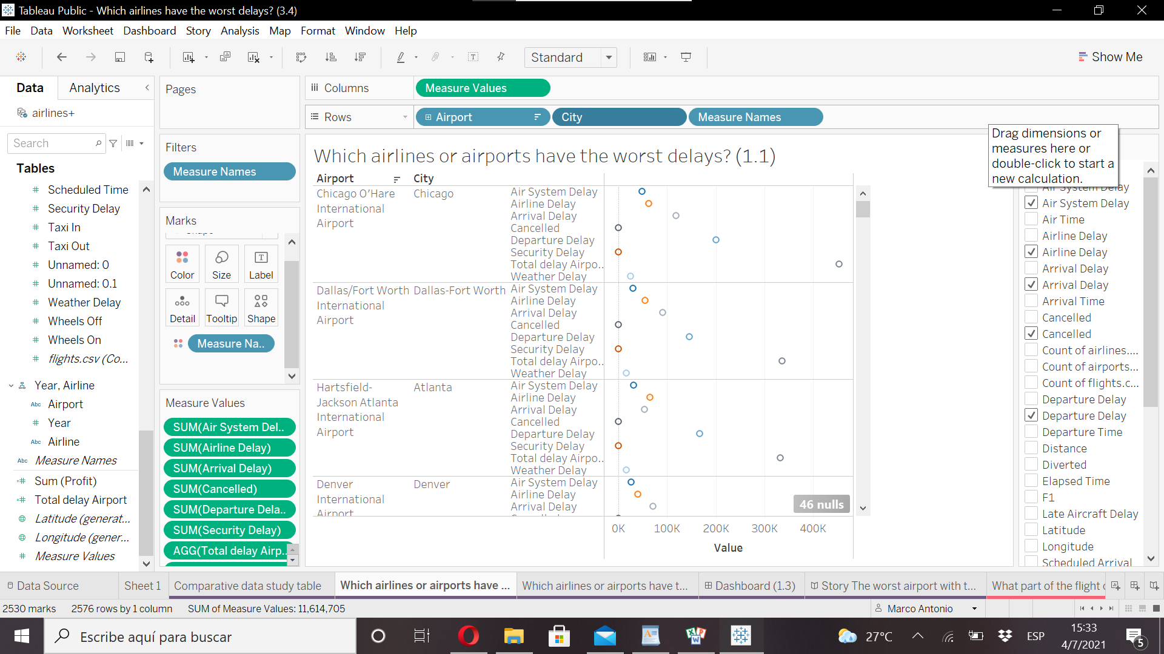In this question I used the graphic **"circular views"** for its simplicity and naturalness applying soft colors, we used a color palette suitable for color blind, each circle composes the data of each "delays" with their respective values, the last circle is the total sum of all the "delays" in answering the question and showing the public also how they can interact with said graphic. Separating each data in airport and the city to which it belongs through the filters on the right side of the graph.

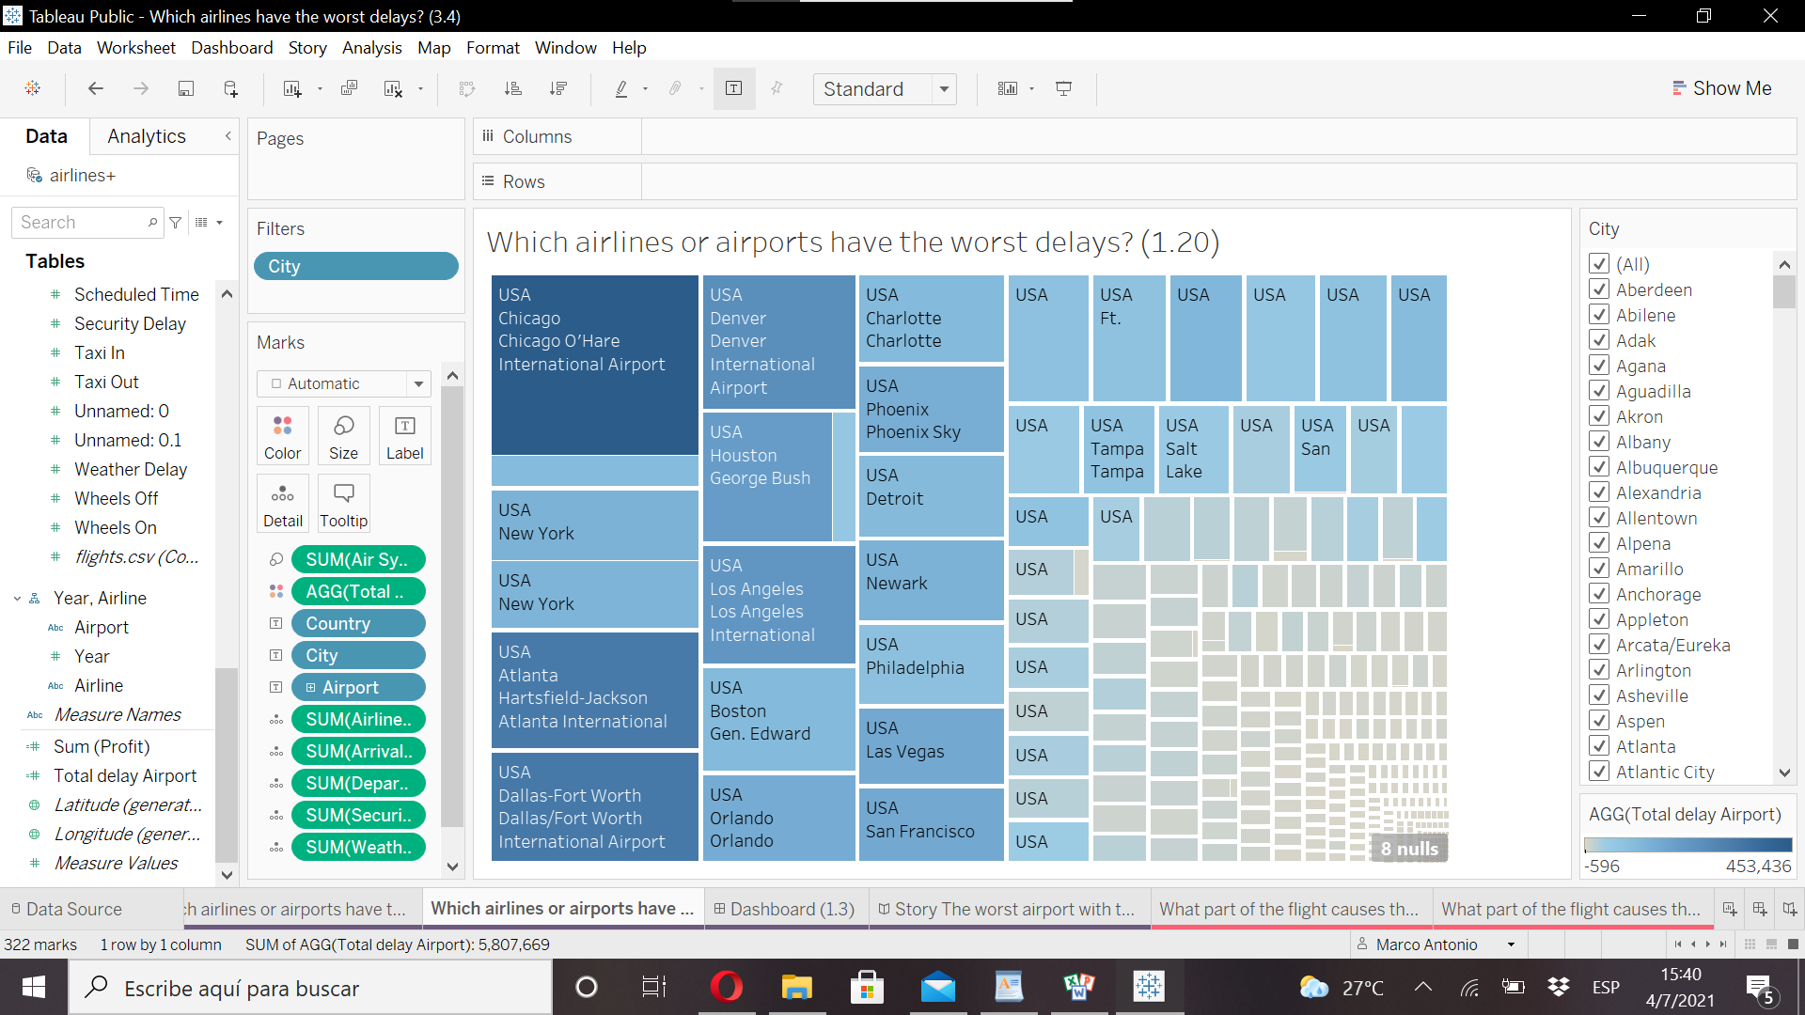We also apply the use of the **"Treemaps"** graphic for this question. With this graph, the use of squares with sizes makes the values ​​of each data distinctive, accompanied by colors in which each color is darker, the data with the greatest number of "delays" is used. And the attenuated color, and of reduced size, represents the opposite of the larger ones; We can also see that each box has the name of the airport and the country of origin, if we bring the pointer to each box we can see a window where it shows the values ​​of each data of "delays" and the total sum of these in order to find among themselves the answer to the question.

We also add a filter table for an interaction with the data.

* Resources:

N/A

**What part of the flight causes the most delays?**

* Links to your dashboards or story:

https://public.tableau.com/views/Whatpartoftheflightcausesthemostdelays2_1/Whatpartoftheflightcausesthemostdelays2_1_1?:language=en-US&:display_count=n&:origin=viz_share_link

* Summary:

In the second question to obtain the answer, we made the total sum of the columns using the "Comparative data study table" as a basis, to find which of the "delay" factors has the greatest number in the incidence of delay and thus we obtained that " Departure Delay "appeared with the highest number when it comes to delays.

* Design:

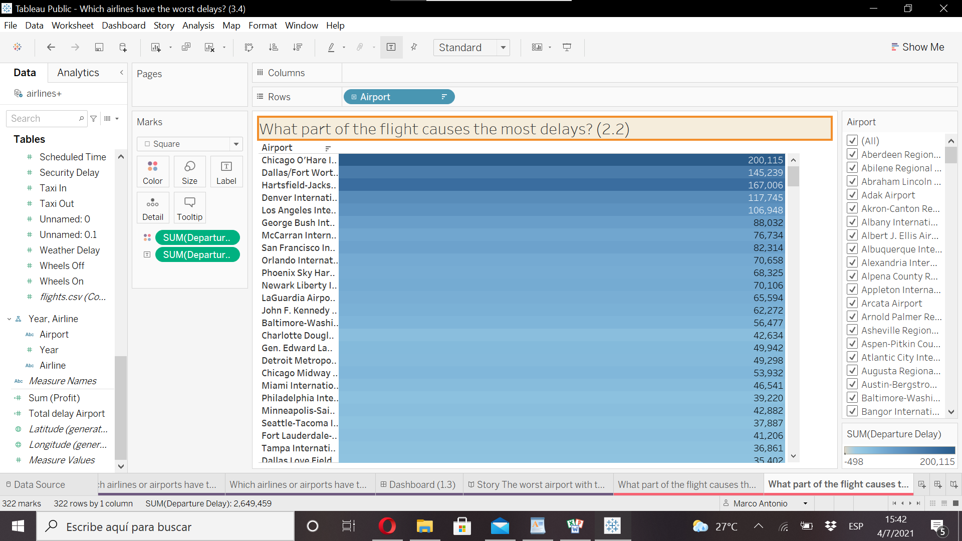Here we use the graph **"Highlight"** with this table accompanied by colors that we also use a suitable color palette for people with color blindness in this table we make a total sum of the data of "departure delay" to obtain which of these airports is the most affected by lifting the pointer to each row we will notice a box that gives us the data "departure delays" and the name of the airport, here we also offer a filter to interact with each airport and see their numbers.

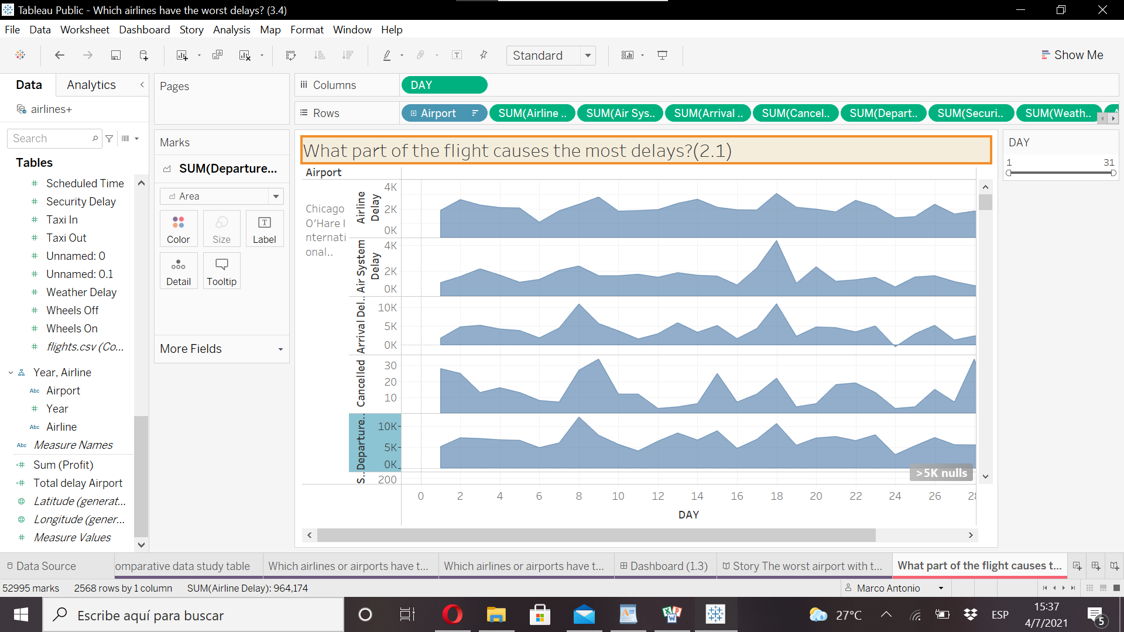Here I decided to use **"Area Charts"** in this graph we represent the days to know in the graph which days the "delays" get worse, knowing that the Chicago O'Hare International Airport in particular are the ones with the greatest "delays" since in the previous question gave us this data, we added the reasons for the "delays" ".

In the graph, if we move the pointer to the areas of the graph, we will see the numerical values ​​of each data and we will make comparisons with the rest of the data presented here.

We also offered a filter on the right side of the chart to interact with the days.

* Resources:

N/A

**Which airlines have the worst delays?**

* Links to your dashboards or story:

https://public.tableau.com/views/Whichairlineshavetheworstdelays3_1/Whichairlineshavetheworstdelays3_1?:language=en-US&:display_count=n&:origin=viz_share_link

* Summary:

The third question is a continuation of the previous ones, since the data showed the Chicago airports with the worst "Dealys" so in continuity with them we decide to take which of those airlines in Chicago has the worst numbers.

* Design:

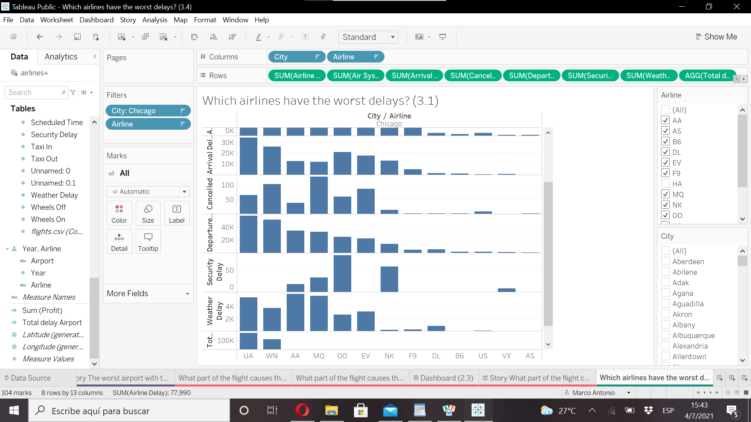We worked with the **"horizontal bar"** chart with the bars representing the totals of the "lag" factors colored in a single color, a color type that is also friendly to people with color blindness. If we direct the pointer to each bar, it will give us the numbers of each factor and through each bar, by its size, we will know how big its level of delay is and it will help us to compare it with the rest of the airlines.

Here we also give viewers the freedom to interact with the charts through the filters for each city and airline.

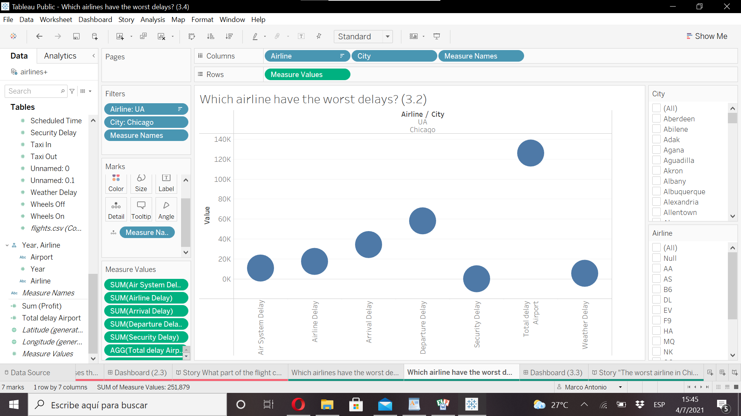

We represent this graphic **"Circle views"** with circles filled in blue, when selecting each circle with the pointer you can see the table that shows the data and quantities of the "delays" factors and also the circle with the value of the sum of all the delay factors, we also accompany this graph with filters to interact with the cities and airlines.

* Resources:

N/A